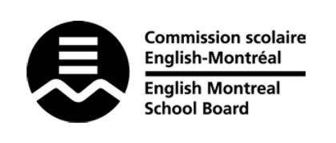
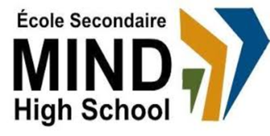

STANDARDS & PROCEDURES

Subject: | Visual Arts
Teachers: | Aline Saba (Sec 1 & 5)  Patrick Stewart-Reid (Sec 2,3,4)
Cycle and Level Taught: | All levels
School Year: | 2025-2026

Term 1 (20%)
Competencies Targeted* | Evaluation Methods* | General Timeline
- Creates personal and media images (70%)  - Appreciates images (30%) | Projects and portfolio of their work throughout the term. | September 2, 2024  to  November 6, 2025
Cross-Curricular Competencies  - Achieves potential  - Solves problems | Continued observation and assessment of progress. | September 2, 2024  to  November 6, 2025
Communication to Students and Parents | Other Pertinent Information
Email  Google Classroom  Progress Report*  *Available on MOZAÏK October 15  Report Card^  ^Available on MOZAÏK November 19  Parent-Student-Teacher Interviews  (November 20) | Students are asked to use different media to produce different pieces, both digital and physical. Students are given handouts for assignments; all details will be posted on Google Classroom.  Students will be assigned projects that can both function as discrete works of art, as well as build on each other to form bigger, more comprehensive pieces. Students will be shown techniques that will allow them to grow as artists and acquire the skills necessary to express themselves creatively.  Various media will be used over the year.

Term 2 (20%)
Competencies Targeted* | Evaluation Methods* | General Timeline
- Creates personal and media images (70%)  - Appreciates images (30%) | Projects and portfolio of their work throughout the term. | November 10, 2024  to  February6, 2025  Various projects  throughout the term using various media.
Cross-Curricular Competencies  - Achieves potential  - Solves problems | Continued observation and assessment of progress; not formally reported in the Term 2 report card.
Communication to Students and Parents | Other Pertinent Information
Email
Google Classroom
Report Card^
^Available on MOZAÏK February 25
Parent-Student-Teacher Interviews
(February 26)

Term 3 (60%)
Competencies Targeted* | Evaluation Methods* | General Timeline
- Creates personal and media images (70%)  - Appreciates images (30%) | Projects and portfolio of their work throughout the term. | February 6, 2025  to  June 23, 2025  Various projects  throughout the term using various media
Cross-Curricular Competencies  - Achieves potential  - Solves problems | Continued observation and assessment of progress.
Communication to Students and Parents | End-of-Year Evaluation* | Other Pertinent Information
Email  Google Classroom  Report Card^  ^Available on MOZAÏK June 26  MEQ Transcript Secondary 4 & 5**  **Ministry exam results as well as credits obtained are communicated by the MEQ via the Achievement Record (accessible via MEQ website and mailed as a hard copy to the students’ homes). More information will be given by the school team as to how to create an MEQ account using each student’s private email. | There is no evaluation at the end of the year.
End of Year Subject Mark
The end-of-year subject mark is a combination of the term marks (20%+20%+60%) and the final exam marks, if relevant. For certain subjects in Secondary 4 & 5, the final mark will be provided by the MEQ, as it will include the result of ministry exams.

* Competencies Targeted and Evaluation Methods may be subject to change.

