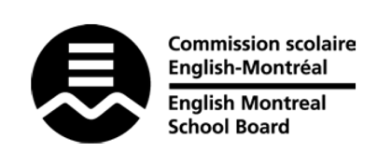
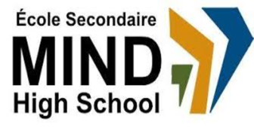

STANDARDS & PROCEDURES

Department or Subject: | Science & Technology
Teacher(s): | Pamela Gómez
Cycle and Level Taught: | Cycle 2, Level 2
School Year: | 2023 – 2024

Term 1 (20%)
Competencies Targeted* | Evaluation Methods* | General Timeline
Theoretical (60%)  Practical (40%) | Quizzes, Tests  Assignments, Labs | Aug. 30 – Nov. 15, 2023
Communication to Students and Parents | Other Pertinent Information
Email  Google Classroom  Mozaïk  Progress Report  Report Card  Parent-Teacher-Student  Interviews | Term 1 focuses on…  the Material World and the Technological World

Term 2 (20%)
Competencies Targeted* | Evaluation Methods* | General Timeline
Theoretical (60%)  Practical (40%) | Quizzes, Tests  Midyear Exam (Jan. 2024)  Assignments, Labs | Nov. 16, 2023 –  Feb. 9, 2024
Communication to Students and Parents | Other Pertinent Information
Email  Google Classroom  Mozaïk  Progress Report  Report Card  Parent-Teacher-Student  Interviews | Term 2 focuses on…  the Material World and Earth and Space

Term 3 (60%)
Competencies Targeted* | Evaluation Methods* | General Timeline
Theoretical (60%)  Practical (40%) | Quizzes, Tests  Assignments, Labs | Feb. 17 – June 21, 2024
Communication to Students and Parents | End of Year Evaluation* | Other Pertinent Information
Email  Google Classroom  Mozaïk  Report Card | Lab Exam (May 2024)  MEQ Final Theory Exam  (June 2024) | Term 3 focuses on…  the Living World and  the Technological World

* Subject Competencies Targeted and Evaluation Methods may be subject to change.

Cross-curricular Competency Evaluated | General Timeline
The cross-curricular competencies evaluated this term are:  - to adopt effective work methods  - to cooperate with others | Terms 1 & 3

