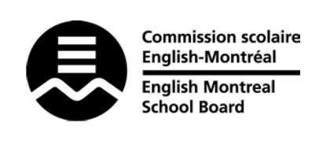
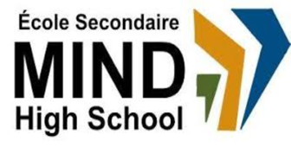

STANDARDS & PROCEDURES

Department or Subject: | Contemporary World History
Teacher(s): | Sherine Boctor
Cycle and Level Taught: | Cycle II – Level V
School Year: | 2023-2024

Term 1 (20%)
Competencies Targeted* | Evaluation Methods* | General Timeline
Think critically about the knowledge process | Class discussions & group presentations | September – mid-October
Communication to Students and Parents | Other Pertinent Information
Progress Report  Report Card  Parent-Student-Teacher  Interviews  Email  Google Classroom | Term 1 focuses on…inflation & economic recession, Covid-19 pandemic, climate change, food insecurity, Ukraine-Russia war (causes & consequences)

Term 2 (20%)
Competencies Targeted* | Evaluation Methods* | General Timeline
Write critically about the knowledge process | Writing news reports | Mid-October-December
Communication to Students and Parents | Other Pertinent Information
Report Card  Parent-Student-Teacher  Interviews  Email  Google Classroom | Term 2 focuses on…invasion of Iraq, 2008-2009 economic recession and bank collapse, WWI, European socio-political issues

Term 3 (60%)
Competencies Targeted* | Evaluation Methods* | General Timeline
Writing a research paper and citing sources | Writing an 8-10 page research paper | January-June
Communication to Students and Parents | End of Year Evaluation* | Other Pertinent Information
Report Card  Email  Google Classroom | Final research paper | Term 3 focuses on WWII & post colonialism in the southern hemisphere…

* Competencies Targeted are understanding the facts of each case, exercising critical thinking, coming to an informed opinion; the terms’ weighting is 20-20-60s

