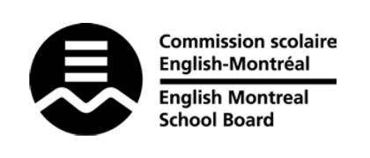
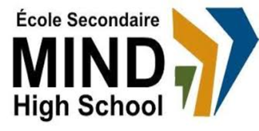

STANDARDS & PROCEDURES

Subject: | CCQ
Teacher: | Patrick Stewart-Reid
Cycle and Level Taught: | Cycle 1 Level 2
School Year: | 2025-2026

Term 1 (20%)
Competencies Targeted* | Evaluation Methods* | General Timeline
Studies cultural realities 50%  Reflects on ethical questions 50% | Through discussion, written reflection, and project based learning:  Proficiency in knowledge  related to cultural realities.  Quality of the procedure.  Understanding of cultural realities. | September 2nd, 2025  to  November 16th, 2025
Cross-Curricular Competencies  - Achieves potential  - Solves problems |  | September 2nd, 2025  to  November 16th, 2025
Communication to Students and Parents | Other Pertinent Information
Email  Pstewart-reid@emsb.qc.ca  Google Classroom  Progress Report*  *Available on MOZAÏK October 15th  Report Card^  ^Available on MOZAÏK November 19th  Parent-Student-Teacher Interviews  (November 20th) | Students will be introduced to various units/topics that deal with culture and ethics in or relating to Quebec. This course is a project-based inquiry that will lead to group discussions and debates. Students are asked to reflect on their learning.

Term 2 (20%)
Competencies Targeted* | Evaluation Methods* | General Timeline
Studies cultural realities 50%  Reflects on ethical questions 50% | Through discussion, written reflection, and project based learning:  Proficiency in knowledge  related to cultural realities.  Quality of the procedure.  Understanding of cultural realities. | November 10th, 2024  to  February 6th, 2025
Cross-Curricular Competencies  - Achieves potential  - Solves problems | Continued observation and assessment of progress; not formally reported in the Term 2 report card. | November 10th, 2024  to  February 6th, 2025
Communication to Students and Parents | Other Pertinent Information
Email  Google Classroom  Report Card^  ^Available on MOZAÏK February 25th  Parent-Student-Teacher Interviews  (February 26th) | Students will be introduced to various units/topics that deal with culture and ethics in or relating to Quebec. This course is an project based inquiry that will lead to group discussions and debates. Students are asked to reflect on their learning.

Term 3 (60%)
Competencies Targeted* | Evaluation Methods* | General Timeline
Studies cultural realities 50%  Reflects on ethical questions 50% | Through discussion, written reflection, and project based learning:  Proficiency in knowledge  related to cultural realities.  Quality of the procedure.  Understanding of cultural realities. | February 7, 2026  to  June 23, 2026
Cross-Curricular Competencies  - Achieves potential  - Solves problems |  | February 7, 2026  to  June 23, 2026
Communication to Students and Parents | End-of-Year Evaluation* | Other Pertinent Information
Email  Google Classroom  Report Card^  ^Available on MOZAÏK June 26  MEQ Transcript Secondary 4 & 5**  **Ministry exam results as well as credits obtained are communicated by the MEQ via the Achievement Record (accessible via MEQ website and mailed as a hard copy to the students’ homes). More information will be given by the school team as to how to create an MEQ account using each student’s private email. | No formal evaluation. | See term 1 and 2.
End of Year Subject Mark
The end-of-year subject mark is a combination of the term marks (20%+20%+60%) and the final exam marks, if relevant. For certain subjects in Secondary 4 & 5, the final mark will be provided by the MEQ, as it will include the result of ministry exams.

* Competencies Targeted and Evaluation Methods may be subject to change.

