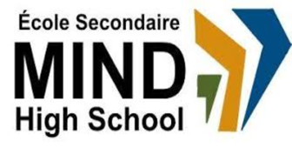

STANDARDS & PROCEDURES

Department or Subject: | Pop Culture & Media & Communication
Teacher(s): | Sherine Boctor
Cycle and Level Taught: | Cycle II – Level V
School Year: | 2023-2024

Term 1 (20%)
Competencies Targeted* | Evaluation Methods* | General Timeline
Thinking critically & deconstructing media | Class discussions & writing reflections | September-November
Communication to Students and Parents | Other Pertinent Information
Progress Report  Report Card  Parent-Student-Teacher  Interviews  Email  Google Classroom | Term 1 focuses on…art as activism, art as a vehicle of values, literary criticism

Term 2 (20%)
Competencies Targeted* | Evaluation Methods* | General Timeline
Read and analyze a variety of media | Writing, creating pop art, class discussions | November-December
Communication to Students and Parents | Other Pertinent Information
Report Card  Parent-Student-Teacher  Interviews  Email  Google Classroom | Term 2 focuses on…critical thinking about pop art, commercial art, fine art

Term 3 (60%)
Competencies Targeted* | Evaluation Methods* | General Timeline
Deconstructing stereotypes and common tropes in media | Discussing a variety of T.V. series, analyzing representations of different communities | January-June
Communication to Students and Parents | End of Year Evaluation* | Other Pertinent Information
Report Card  Email  Google Classroom | Producing a creative narrative about a miss-represented, underrepresented or stereotyped community | Term 3 focuses on…analyzing various films and television series

* Competencies Targeted discusses actively in class + creates pop art + writes critically on pop art. All three competencies are evaluated every semester. The terms weighting is 20-20-60.

