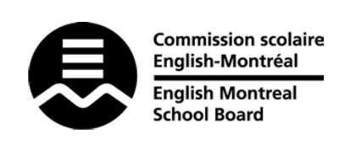
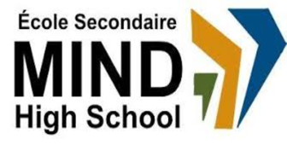

STANDARDS & PROCEDURES

Department or Subject: | German as a Third Language
Teacher(s): | Aline Saba
Cycle and Level Taught: | Cycle II; Secondary 5
School Year: | 2023-2024

Term 1 (20%)
Competencies Targeted* | Evaluation Methods* | General Timeline
Speaking (40%)  Reading (30%)  Writing (30%) | Projects, presentations, in-class assignments | August 30th, 2023 to November 15th, 2023  Discussions throughout  the term; projects at the  end of each unit
Communication to Students and Parents | Other Pertinent Information
Progress Report  Report Card  Parent-Student-Teacher  Interviews  Email  Google Classroom | Term 1 focuses on the basics of the German language: how to describe oneself, how to count, how to conjugate basic verbs and write basic sentences.

Term 2 (20%)
Competencies Targeted* | Evaluation Methods* | General Timeline
Speaking (40%)  Reading (30%)  Writing (30%) | Projects, presentations, in-class assignments | November 15th, 2023 to February 9th, 2024  Discussions throughout  the term; projects at the  end of each unit
Communication to Students and Parents | Other Pertinent Information
Report Card  Parent-Student-Teacher  Interviews  Email  Google Classroom | Term 2 focuses on building more complex sentences and watching/listening to more German media.

Term 3 (60%)
Competencies Targeted* | Evaluation Methods* | General Timeline
Speaking (40%)  Reading (30%)  Writing (30%) | Projects, presentations, in-class assignments | February 12th, 2024 to June 7th, 2024  Discussions throughout  the term; projects at the  end of each unit
Communication to Students and Parents | End of Year Evaluation* | Other Pertinent Information
Report Card  Email  Google Classroom |  | Term 3 focuses on consolidating our learning through the writing of longer paragraphs and simulating real-life situations.

* Competencies Targeted and Evaluation Methods may be subject to change.
Local and EMSB exams are worth 30%.
MEES exams are worth 50%.

